School of Computer Science and Artificial Intelligence

LabAssignment-10.2

Program :B.Tech(CSE) Specialization :AIML
Course Title :AI Assisted Coding Course Code : 23CS002PC304
Semester : VI AcademicSession :2025-2026
Name of Student: Nitesh Kumar
Enrollment No. : 2303A52098 Batch No. : 33
Date :17-2-2026
Lab 10 – Code Review and Quality: Using AI to Improve Code
Quality and Readability

Lab Objectives
• Use AI for automated code review and quality enhancement.
• Identify and fix syntax, logical, performance, and security issues
in Python code.
• Improve readability and maintainability through structured
Week5 -
Tuesday
refactoring and comments.
• Apply prompt engineering for targeted improvements.
• Evaluate AI-generated suggestions against PEP 8 standards and
software engineering best practices

Task 1 – Error Detection and Correction
Issues in Given Code

- Missing colon : after function definition.
- Wrong indentation.
- Missing colon in for loop.
- Variable total not defined (should return sum).
- Avoid using built-in name sum as a variable.

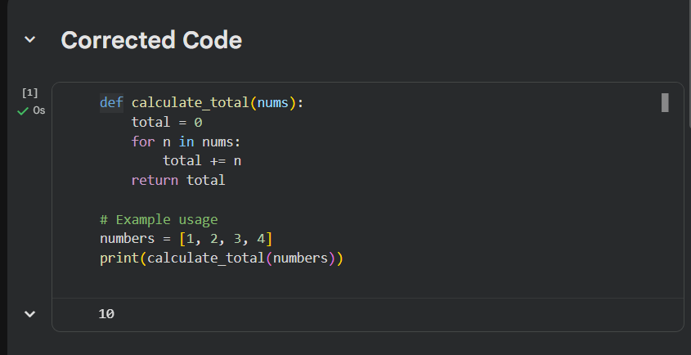

Fix Summary
- Added missing : symbols.
- Corrected indentation.
- Replaced undefined variable.
- Used total instead of built-in sum.

Task 2 – Code Style Standardization (PEP 8)

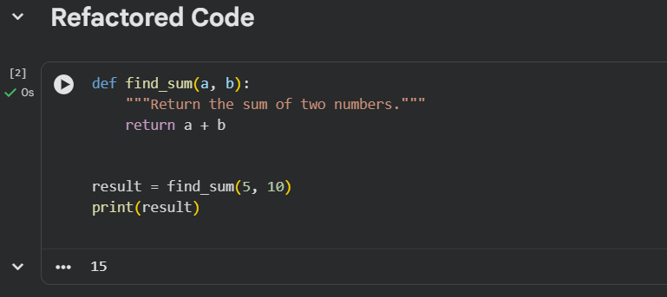

Improvements
- Function name changed to snake_case.
- Added docstring.
- Proper spacing and formatting.

Task 3 – Code Clarity Improvement

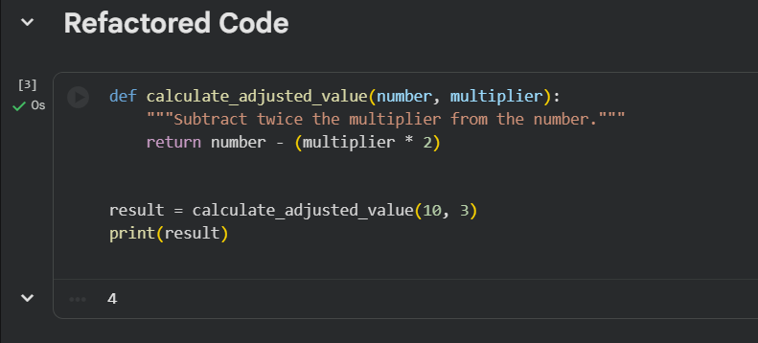

Improvements
- Meaningful function and variable names.
- Added explanation through docstring.
- Improved readability.

Task 4 – Structural Refactoring (Reusable Functions)

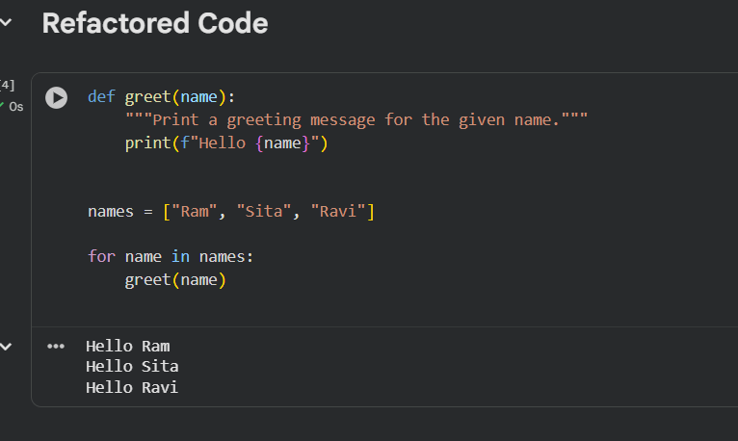

Improvements
- Removed repetition.
- Created reusable function.
- Used loop for scalability.

Task 5 – Efficiency Enhancement

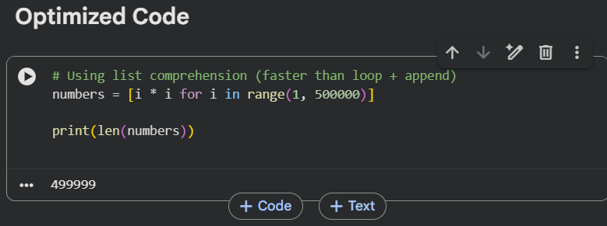

Why Faster?
- List comprehensions are optimized in Python.
- Avoids repeated method calls (append).
- Cleaner and more memory-efficient.

Conclusion (For Lab Submission)
Using AI-assisted review helped to:
- Fix syntax and logical errors.
- Improve code readability and structure.
- Ensure compliance with PEP 8.
- Reduce redundancy through modular design.
- Optimize performance using Python best practices.

